**Report: Internship Task - Dashboard Creation for Sprocket Central Pty Ltd**

**Objective:**

The objective of this task was to develop a visually appealing and interactive dashboard using tools like Power BI or Tableau to present data summary and analysis results to the client, Sprocket Central Pty Ltd.

**Approach:**

1. Data Analysis: Conducted a thorough analysis of the provided dataset to identify trends and insights relevant to the client's business context.

2. Visualization Selection: Leveraged the capabilities of Power BI to select appropriate visualizations that effectively communicate the analysis findings.

3. Dashboard Design: Designed a user-friendly dashboard with a maximum of 3 views/tabs, incorporating creativity in layout and presentation to enhance visual appeal.

**Key Findings and Recommendations:**

1. Main Goal of the Analysis: The main goal of this analysis was to provide predictive insights on which of the new potential customers Sprocket Central should focus on to maximize sales in terms of margin and revenue.

2. Recommendations for Identifying Potential Customers:

- Job Industry: Industries with the highest margins, such as Manufacturing and Financial Services, should be prioritized for filtering potential customers.

- Geographic Location: New South Wales has the highest concentration of high-margin customers, so filtering potential customers from this region is recommended.

- Age Group: Customers between the ages of 20 and 60 represent the largest customer base in terms of volume, sales, and margins. Therefore, focusing on this age group is advised.

- Wealth Segment: The Mass Customer segment outperforms the other two segments by a significant margin. Hence, potential customers from this segment should be prioritized.

3. Targeting Potential Customers:

- The list showcases potential customers who are likely to purchase high-margin products based on predictive analysis. Sprocket Central should focus on these customers and prioritize their sales efforts accordingly.  
  
  
  
  
  
  
  
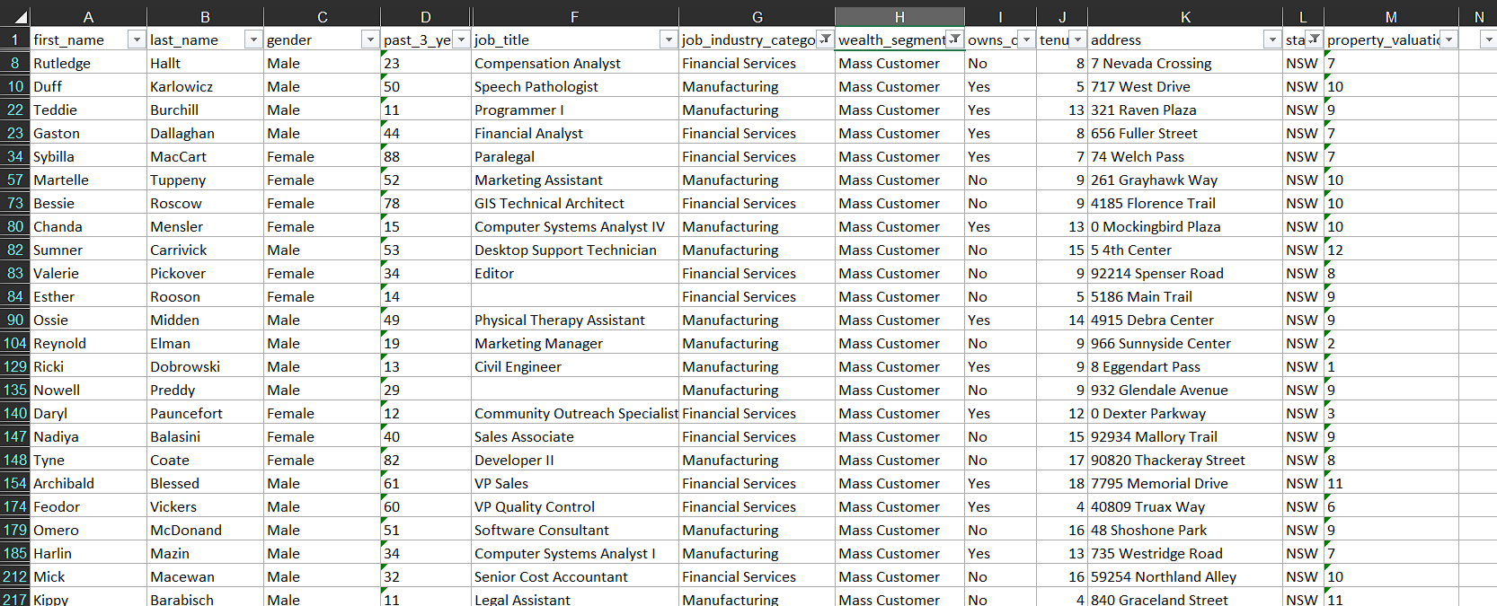

- Additionally, the company should implement robust sales and marketing strategies to attract customers from other segments and bring them onboard.

**Mindset and Approach:**

1. Business Context: Maintained a strong focus on the business context throughout the analysis and dashboard creation process.

2. Creativity: Incorporated creativity in layout and presentation to ensure the dashboard is visually appealing and engaging for the client.

3. User-Friendly Design: Prioritized user-friendliness by selecting intuitive visualizations and organizing the dashboard in a logical manner.

4. Data-Driven Insights: Ensured that all recommendations and findings were backed by data analysis, providing the client with actionable insights.

**Conclusion:**

The developed dashboard effectively presents the data summary and analysis results to the client, Sprocket Central Pty Ltd. By leveraging visualizations and interactive features, the dashboard highlights key findings, trends, and recommendations. The incorporation of the client's logo adds a personalized touch to the deliverable. Overall, the dashboard serves as a valuable tool for the client's marketing team to make informed decisions and drive growth.

Please let me know if there's anything else I can assist you with!